National University of Computer and Emerging Sciences



Lab Exercise 07

CL461-Artificial Intelligence Lab

|  |  |
| --- | --- |
| Course Instructor | Dr. Mubashir baig |
| Lab Instructor (s) | Nimra Abbas  Samia Akhtar |
| Section | H |
| Semester | Spring 2022 |

Department of Computer Science

FAST-NU, Lahore, Pakistan

# Exercise (40 Marks)

Attempt all tasks given below.

## Make a Soccer PlayerWeight PieChart (20 Marks)

Consider the following dataset: **fifa_data.csv**

Make a pie chart using Matplotlib, similar to the one shown below:

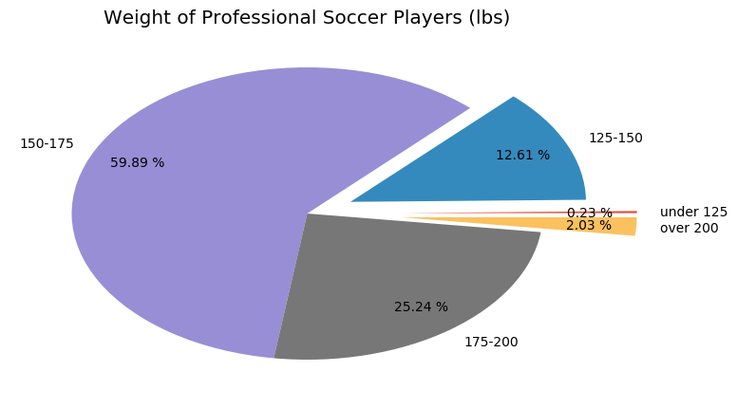

## Create a Histogram, Bar-graph, and Box plot as well.

# Submission Instructions

Always read the submission instructions carefully.

* Put all your code in 1 Jupyter notebook.
* Rename your Jupyter notebook to your roll number and download the notebook as **.ipynb** extension.
* To download the required file, go to **File->Download .ipynb**
* Only submit the **.ipynb** file. DO NOT**zip** or **rar** your submission file
* Submit this file on Google Classroom under the relevant assignment.
* Late submissions will not be accepted